EX NO:
DATE:
WITHDRAW MONEY AND RECEIPT IN ATM
GIVEN:
The given Use Case Diagram represents the functional behavior of the ATM Withdrawal System for withdrawing ₹1000 and generating a receipt.
AIM:
The system boundary is clearly defined as ATM SYSTEM, inside which all use cases are placed. The primary actor is the User, who initiates the withdrawal transaction. The supporting actors include the Bank Server for authentication and authorization and the Dispenser (for cash dispensing and receipt printing.
Observation of Actors
1.User
Initiates the transaction.
Inserts the card.
Chooses account type.
Selects withdrawal option.
Selects amount (₹1000).
Receives cash and receipt.
2,Bank Server
Validates card details.
Authenticates user credentials.
Checks account balance.
Authorizes transaction.
3.Dispenser
Dispenses cash.
Prints receipt.

USE CASE DIAGRAM:
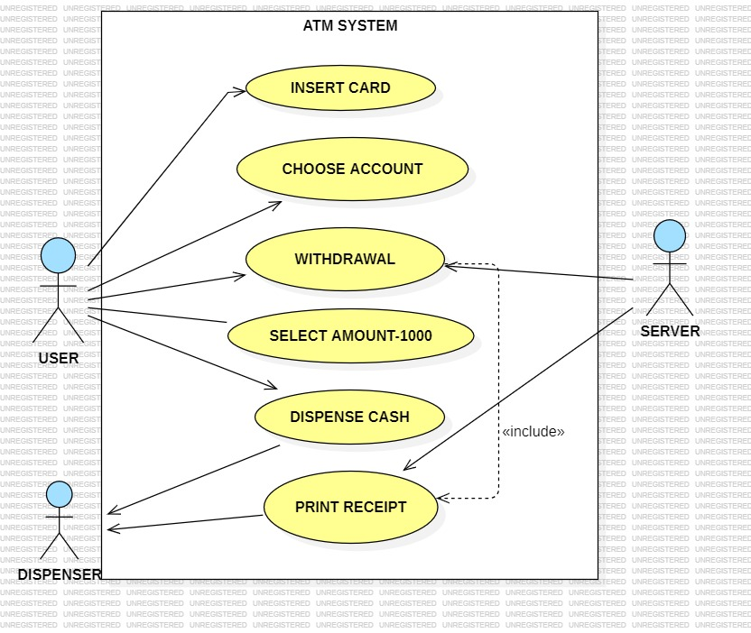
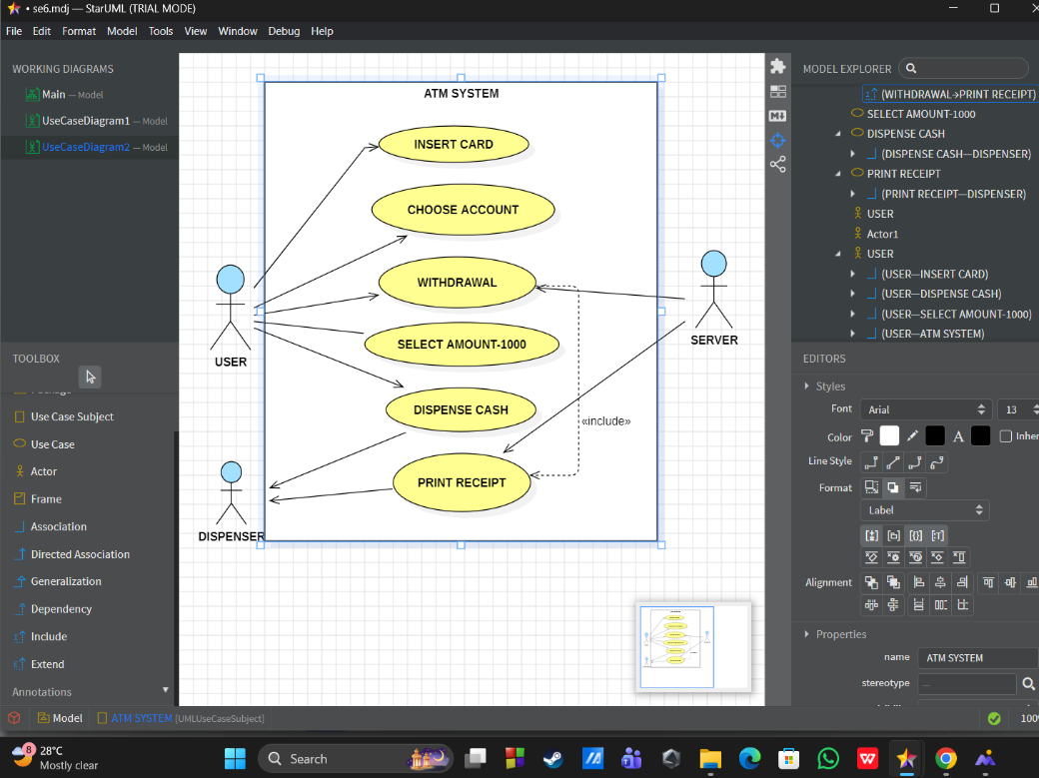

WORKING:
The main use case is:
1.Withdrawal
This use case includes the following sub use cases:
1.Insert Card
2.Choose Account
3.Select Amount – ₹1000
4.Dispense Cash
5.Print Receipt
The relationship «include» is used to show that:
1.Withdrawal includes Dispense Cash.
2.Withdrawal includes Print Receipt.
This means dispensing cash and printing receipt are mandatory steps in the withdrawal process

System Behavior :
- User inserts the card into ATM.
- System authenticates user via Bank Server.
- User selects withdrawal option.
- User selects account type.
- User enters/selects amount (₹1000).
- System checks balance through Bank Server.
- If sufficient balance:
1.Cash is dispensed.
2.Receipt is printed.
Thus, the Use Case Diagram clearly represents the functional requirements and interaction between actors and ATM system.

Conclusion :
The Use Case Diagram successfully illustrates:
1,External actors interacting with the ATM system.
2.Functional steps involved in withdrawing ₹1000.
3.mandatory inclusion of cash dispensing and receipt printing.
4.Proper separation between system boundary and external entities.

RESULT:
Thus the UML use case diagram for the ATM withdrawal system were successfully designed and their working was studied susccessfully,

